Yorklands Green Hub Project Application
Please fill in the application for your project. The more detail provided, the easier it will be to see if your project fits our Vision for the Yorklands property:
Yorklands Green Hub aims to create for Ontario’s public domain a self-sustaining education, demonstration, and research hub at the provincially owned former Guelph Correctional Centre (GCC).
Yorklands Green Hub will bring together businesses, organizations, and people of all ages and interests – to learn, work, share and innovate, with the common purpose of being engaged stewards of our land, food, water, and our overall wellbeing.
The three principal areas of activities will be Local Food Production and Security, Water and Resource Conservation, and Energy and Transportation. For further information, please visit http://www.yorklandsgreenhub.ca/.
Project Title: Passive Solar Greenhouse for Year Round Vegetable Production
Description of Activities: Build a passive solar greenhouse that would allow year round vegetable production of spinach, kale, as well as some other leafy greens. The greenhouse would not require supplemental heat to stay above freezing in the winter months, even when outdoor ambient temperatures reached -30C. The greenhouse would use water and concrete to store heat throughout the day and maintain heat throughout the night. Once constructed, the structure footprint would be under 100 square feet and have a lifespan of 30-40 years and require minimum upkeep.
Expected Outcomes, quantify as possible:
Time Frame | Environmental | Social | Economic
Within one year | -Use sustainable, environmentally friendly materials to build a greenhouse from the foundation up | -Ability to have a hands-on approach to community members by helping build a small passive solar greenhouse that could be copied for residential use | -Greenhouse is built for less than the cost of purchasing a similar size, all glass greenhouse
After two years | -Without supplemental heat, no greenhouse gases would be produced for heating the greenhouse | -Community members see the usefulness of the design and are able to grow and consume food grown in greenhouse | -Greenhouse would produce food for human consumption  -Little to no upkeep costs of the greenhouse
Longer term | -Greenhouse would produce local food with no transportation greenhouse gases emitted | -Community members could start building their own, improved versions of the greenhouse in residential areas within Guelph to produce their own food year round | -Little to no upkeep costs of the greenhouse  -Greenhouse would be an attraction for tours and hands-on seminars and workshops regardless of what time of year
How will the project sustain itself? Are there revenue streams that flow from these activities? Do you have sources of funding to cover any shortfalls?
The project would require $3000 upfront for materials and delivery of materials. The greenhouse would have no real revenue streams aside from the produce that is grown within the greenhouse. No sources of funding at this time.
What staff and/or volunteer hours will be needed? Do you have people available?
Greenhouse would take ~200-300 man hours to construct. Volunteer help would reduce time required to build greenhouse.
What space (land, rooms) is required?
100 square feet of land with vehicle and electrical access for tools.
What equipment is needed? Do you have the equipment or the means to acquire it?
Most if not all equipment could be supplied by volunteers.
Could the activities carry some risk to your participants, staff, volunteers or other people on the property? If so, can you acquire insurance to indemnify the Yorklands Green Hub from those activities? Remember that even something as simple as using tools carries some risk.
Construction activities of the greenhouse would carry risk to participants helping. Volunteers, participants and staff could sign waivers to eliminate liability of the Yorklands Green Hub of any accidents or mishaps.
Please attach a month by month, one-year cash flow for your activities in the following format:
 | Month 1 | Month 2 , etc
Revenue Source | TBD | 0
Costs
Greenhouse materials | 2844.85 | 0
Unidentified materials | 500.00
Delivery, tool rental, vehicle costs | 1000.00 | 0
Total Costs | 4344.85 | 0
Net Cash | (4344.85) | (4344.85)
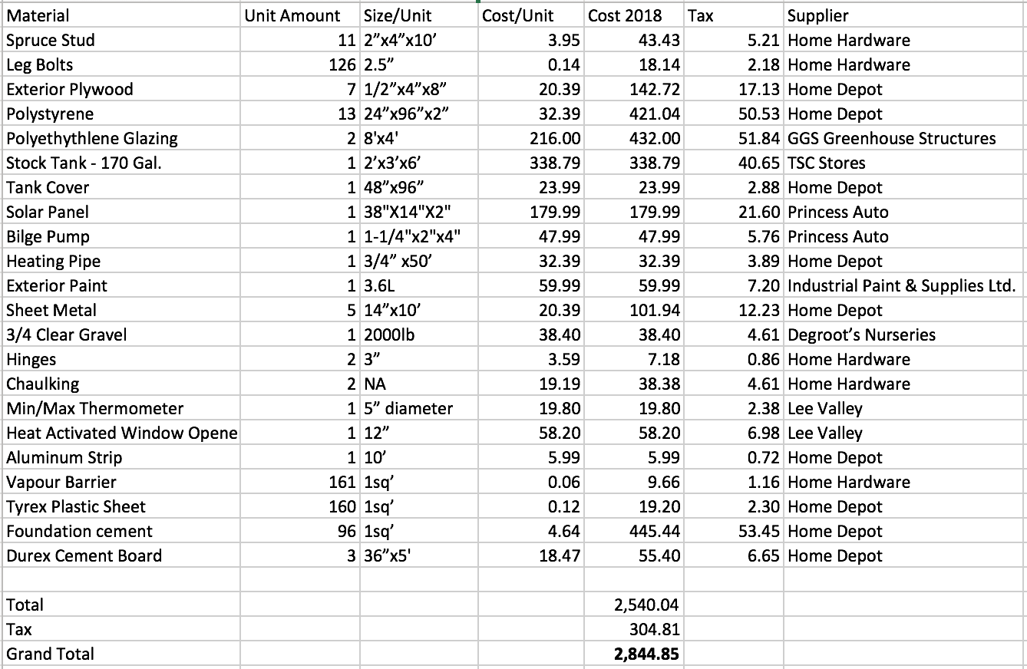
Please attach any other information that will help explain the nature of your project.
Vision for a Passive Solar Greenhouse by Travis Cranmer
To create a <100 square foot greenhouse that maintains an internal temperature above freezing (0°C) without a back-up heat source. The greenhouse materials will cost under $4000. This innovative design should alleviate problems found in other greenhouses, such as water collection, extreme temperatures and winter frosts.

Green Goals
The greenhouse will use as many materials as possible that will be; (In order of importance)
Local
Canadian
Low Carbon Footprint

Summary of Greenhouse Goals:
<100 sq ‘
min temp of 0°C (with no back-up)
material cost ~$4000
correct angle for given latitude
potting room - double door entry
high R-Value Walls
green materials

Consumer Characteristics
Homeowners are looking for a way to grow vegetables year round in a cost effective manner. Currently, small backyard greenhouses on the market require a substantial amount of backup heat in order to maintain an internal temperature that is fitting for garden plants to survive. Using a heat source is contrary to the idea of a greenhouse. Without a large heat capacity, temperatures fluctuate easily within these structures which make conditions not favourable for new seedlings.

Current Greenhouse Designs
Many designs exist on the market ranging from aluminum frame with polyethylene coverings to redwood and double-pane glass. R-values (measure of thermal resistance/insulation value) vary from 1.7 up to 5 with special solar glazing added. Very few models can be found that have a high heat capacity. The problem greenhouses have, in general, is a low thermal mass. (Gauthier et al., 1997)
A small sample of greenhouses available in the market (2011) is given in Fig. 1 below.
Figure 1: Three Greenhouses Available in Canada (2011)

 | Palram 6’x8’ | Sturdi-built Solite  8‘x12’ | Robson Five-Wall 8' x 12'
 | 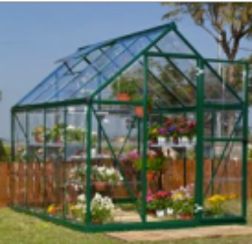 | 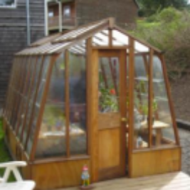 | 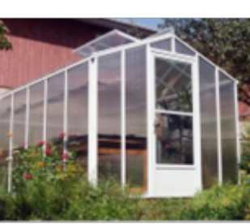
Purchased from | Home Depot (2011) | Studi-Built (2011) | Backyard Greenhouses (2011)
Square Footage | 48 | 96 | 96
Approx. R-value | 1.7 | 5 (with solar glaze) | 3.03
Frame Material | Aluminum | Redwood | Aluminum
Automatic Vent | $99 | $50 | included
Extra Thermal Glazing | $100-$200 | $1308 | max available
Total Cost (CAN) | $1019 | $6796 | $5875

Passive Solar Greenhouse Literature Review
Passive solar infrastructure is when the mass of the building itself acts as the necessary thermal storage material, storing excess solar energy during the sunny hours and releasing it during the night. (Givoni, 1991) All greenhouses collect solar energy. Passive solar greenhouses are designed not only to collect solar energy during sunny days but also to store heat for use at night or during periods when it is cloudy. (Bellows, 2003)
Passive solar greenhouses differ from conventional greenhouses in four main ways. Solar Greenhouses:
- Have glazing orientated to receive maximum solar heat during the winter
- Use heat storing materials to retain solar heat
- Have large amounts of insulation where there is little or no direct sunlight
- Use glazing material and glazing installation methods that minimize heat loss
- Rely primarily on natural ventilation for summer cooling (Bellows, 2003)

Classification of Passive Solar Greenhouses
There are five categories of passive solar greenhouses according to the type of heat storage medium used. These are water, rock bed, latent heat, soil storage with buried pipes and other, (which normally comprises of variations of the other four). Classification of these passive solar greenhouses is easy, however, analyzing, predicting, and evaluating their thermal performance is a complex task. (Anderson, & Michal, 1978)

Water Storage
The heat storage medium is usually placed inside the greenhouse, where the heat exchange is allowed to directly flow between the system and the indoor air of the greenhouse. (Santamouris et al., 1994b) Water has a heat capacity of 4.18 kJ/kgK making it a cheap and easy source of material to hold heat in a greenhouse setting. Water can be exposed to solar radiation through a solar hot water heater, pipes along glazing, pipes along the back north wall or just in the form of a storage tank taking in excess heat throughout the day. At night, the stored heat is transferred back to the lower-temperature air of the greenhouse causing a slower fluctuation of interior greenhouse temperature. (Santamouris et al., 1994b)
Water can be kept in a closed container so evapouration does not decease content and add to excessive humidity to the greenhouse.
Jordan, (1981) patented a plant watering system that is controlled and operated in cycles by the heating effects of the sun. The system included several water tanks which relied on vapour pressure and air relief based on the heat from the sun to water the plants and exchange water between the reservoirs. This invention allows plants to be watered in the presence of the sun without the use of electrical means. Unlike timer systems, which regularly water plants at intervals and take no account to varying climatic conditions, this system would water plants only when the sun was causing the plants to photosynthesize. Although the system was not intended to be used as a passive solar heat system, it definitely would assist in providing some buffer to a fluctuating daily temperature.
Smaller-sized containers, such as glass bottles are more effective than larger containers in providing heat storage in areas with frequent cloud or colder climates. The smaller-size container has a higher ratio of surface area, resulting in more rapid absorption of the heat when the sun does shine. Clear glass containers provide the advantages of capturing heat better than dark metal containers and they will not degrade as other materials. However, they can easily be broken and awkward to store. (Bellows, 2003) These smaller-sized containers could be placed on shelves on the back north wall if shelving was provided to increase the heat capacity.

Rock Bed Storage
Rock bed storage can basically use any size of rock. Studies in greenhouses used 20-100 mm diameter gravel as it has a higher surface area than cobbles and is easier to handle. This gravel can be enclosed in an insulated concrete storage enclosure underneath the floor of the greenhouse. During the day, excess heat is transferred from inside the greenhouse to the underground store and during the night the rock warms the greenhouse above. (Santamouris et al., 1994a)
Soil conductivity also plays a roll in determining how fast heat is given off from a rock storage medium below. Conductivity depends on the physical structure of the top layers of earth and the moisture content. If the soil in a greenhouse is moist the conductivity is likely to be high at all times. (Morrison, 1980)
Rocks can also be incorporated into the North storage wall in the form of masonry or compiled in pails. While stone only has a specific heat capacity of .79-.84 kJ/kg K (depending on the rock) it is not as efficient as water for stabilizing the fluctuating temperature throughout the day.
Two identical polyethylene tunnel type greenhouses with 15m² of ground area were studied by Kurklu et al., (2002) with excavated canals filled with rocks in one greenhouse. The rock-bed system created an air temperature difference of about 10°C at night. The solar energy collection efficiency of the system was 34% with an energy recovery of over 80%. (Kurklu et al., 2002)

Latent Heat Storage
Latent heat materials are mediums that have a higher heat capacity than water. Materials such as calcium chloride hexahydride, (CaCL₂6H₂O) have a melting temperature of 25°C and a latent heat of 154900 kJ/m³. The heat storage is usually placed in a well insulated area or used in the North wall. The material must be replaced every 1-2 years and if stored underground it makes this task difficult. This type of system operates only during the periods at which the temperature inside the greenhouse is significantly higher than the melting temperature of the latent heat material, which means if calcium chloride hexahydride is used, the temperature must be over 25°C before the storage becomes active. Greenhouses that have used latent heat storage have an average payback period of around four years. (Santamouris et al., 1994b)

Soil Storage with Buried Pipes
The soil temperature remains 2-3°C higher than the winter temperatures, in depths only a few meters from the ground surface. Therefore, soil can also be viewed as an easily accessible heat storage medium which is widely available. Using plastic or aluminum buried pipes, excess heat is transferred from inside the greenhouse through the buried pipes into the ground. At night, the ground gives off heat and helps the greenhouse from fluctuating with the exterior temperature. The most efficient greenhouses can maintain a temperature of 10°C higher than the exterior temperature. Depending on the size and types of pipe used to complete this design, the average payback period is estimated to be anywhere from 2.3 to 9.8 years. (Santamouris et al., 1994b)
The optimum tube size for transparent, water-filled polyethylene tubes has been researched in the past specifically for a greenhouse passive solar heating and cooling system by Pavlou. (1989) However, water was continually moved through the pipes, even when it was cloudy.
During high radiation levels followed by mild minimum air temperatures, the release efficiency was usually slightly higher in the small tubes. During unfavourable, low radiation levels, the superiority of the big tubes over small ones was clear. This experiment was conducted using a 3 m side wall of .30mm thick plastic roof. The tubes were made from UV-PR-film with wall thickness of .15mm with 5 different circumference; (80, 90, 100, 110, & 120). These tubes were placed on the ground. (Pavlou, 1989)

Other Types of Heat Storage
To reduce construction costs resulting from the implementation of the previously presented types of heat storage systems, it may be preferable to use insulated sides for reducing heat losses as well as constructing a north storage wall. The north, west and east walls of the greenhouse could be sheltered by local soil to minimize heat loss. The biggest issue encountered using this method is providing structural support to minimize damage from the weight of the soil on the greenhouse.
Thermal storage using exterior underground pipes (geothermal or ground air collector) has been used in an experimental greenhouse. (Fig. 2) The costs are high and the system requires a CPU in order for the system to operate efficiently. This greenhouse had a 6–7°C increase in temperature from the ambient during the night.(Jain & Tiwarni, 2003)

Figure 2: Geothermal Greenhouse showing Ground Air Collector and a Brick North Wall (Jain & Tiwari, 2003)
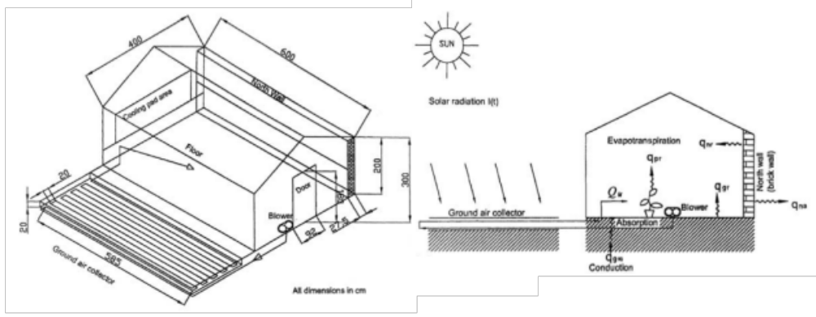

The north storage wall of any passive solar greenhouse may be externally insulated and internally painted black to help it capture heat throughout the day. A portion of the inside surface of the north wall was painted black to assess the advantage of having a darker colour for maximum absorption of solar energy. The wall surface was found to be 3-5°C warmer than the internal temperature of the greenhouse. (Beshada et al., 2006)
In instances where the north wall cannot store heat Hartz, et al., (1981) found by painting the north wall with a reflective white coating it was capable of reflecting 93% of the incident solar radiation and therefore allowing it to be stored elsewhere in the greenhouse. This particular greenhouse required 14% less energy for heating between March and October than a conventional greenhouse.
The use of solar electric photovoltaic heating systems for greenhouses is not cost-effective with current fuel prices unless you are producing high-value crops (Bellows, 2003) and are able to support a high start-up cost.
Reflective blinds have been used to retain the direct solar ration and increase the light availability for plant growth. (Santamouris et al., 1994b) However, the set-up involved in applying or removing the blinds is often too labour intensive if an automated system is not set up for use on a daily basis.
A combination of both a north storage wall and insulated thermal curtain has been used to construct a cost-effective greenhouse in northern latitudes of mainly China. A prototype built in Elie, Manitoba (50°N; 97°W) used the same materials as ones found in northern China. The south-facing wall has a single layer plastic cover and a thermal blanket is put over top every night. (Fig. 3) The north wall (as seen in Fig. 4) from the outside in is comprised of corrugated galvanized steel, fiberglass, plywood, sand, and galvanized sheet metal on the interior. The coldest recorded temperature in February inside was 1.6°C when the outdoor temperature was -29.2°C. To maintain the night temperature at 10°C in this particular greenhouse, supplemental heat up to 17 W/m² would be required for 19 hours per day in the month of February. (Since this greenhouse was 30m long, 8679 watts would be required per day) The operation of the thermal blanket (opening and closing times) should be optimized to avoid the high demand for supplemental heat. (Beshada et al., 2006)
Fig. 5 shows a comparison of several passive solar greenhouse types as recorded by Santamouris et al. (1994b)

Figure 3: Side View of a Solar Energy Greenhouse (Breshada et al., 2006)
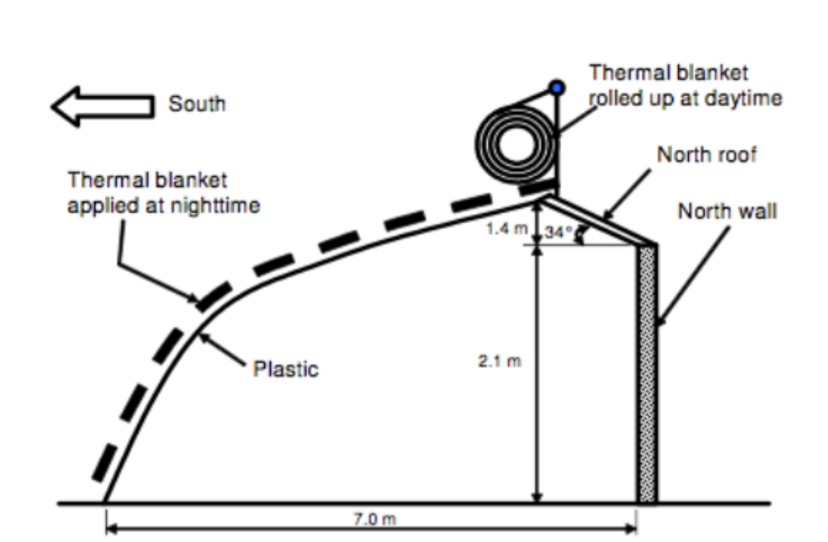Figure 4: Structure of the Solar Energy Storage (North) Wall (Breshada et al., 2006)
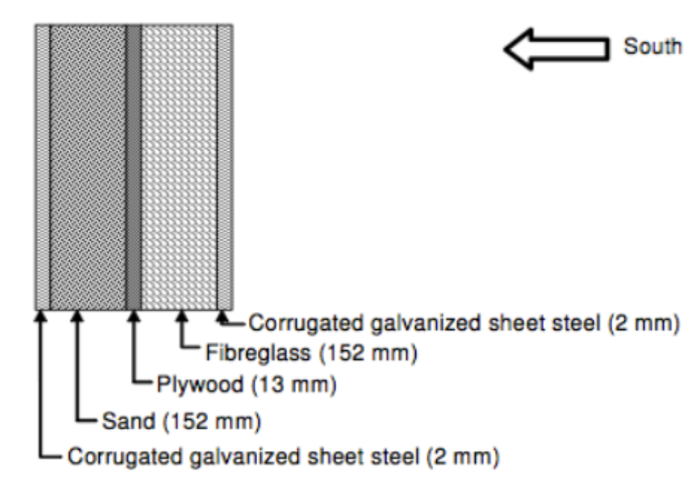
Figure 5: A Comparison of Several Greenhouse Types and their Temperature Above Ambient During a Cold Night by Santamouris et al., (1994b)

Greenhouse Type | Described/Built by (date): | South Wall Material | Area of Greenhouse (m³) | Amount of Material (m³) | Where material placed | Temperature above ambient (Cold night)
Water Storage | Fourcy (1982) | Glass | 150 | 4 | North Wall Barrels | 10°C
Water Storage | Mercier (1981) | Double Glass | 150 | 19.7 | Underground | NA
Water Storage | Grafiadellis, (1987) | Polyethelene | 500 | NA | Underground | 4-6°C
Water Storage | Pacheco (1987) | Polyethelene | NA | 1/bag | Polyethylene bags | 2.5-4°C
Water Storage | Liskola (1987) | Filon | <100 | NA | North Wall Barrels | 12°C
Water Storage | Picciurro (1988) | Polycarbonate | 100 | 5.76 | North Wall Barrels | NA
Water Storage | Straub (1978) | Glass | <100 | 0.018 | Ground Tank | 4-5°C
Latent Heat | Jaffrin (1982) | Glass | 5000 | 13.5 tons | Underground | 10-15°C
Buried Pipes | Coffin (1985) | Fibreglass | <100 | NA | North wall, underground | 10°C
Buried Pipes | Yoshioka (1989) | Polyethelene | <100 | NA | Underground only | 4°C
Buried Pipes | Bascetincelik (1987) | Polyethelene | 835 | NA | Underground only | 5°C
Rock Bed | Bredenbeck (1987) | Triple Layer Poly Carbonate | 100 | NA | Beds throughout greenhouse | .3/m³/m²
Insulated North Wall | Francois (1987) | NA | NA | NA | 60cm wide storage blocks | 15-20°C

In summary of Santamouris et al., (1994b) comparison, passive solar greenhouses using water storage with ground tubes can result in inside air temperatures 2- 4°C higher than the minimum outdoor air temperature. The use of water barrels can satisfy 70-75% of the annual heating needs or achieve inside temperatures 2-10°C higher than the ambient temperature. The use of water tanks can achieve inside temperatures 2-15°C higher than night outdoor temperatures and cover 20- 50% of the annual heating requirements. (Santamouris et al., 1994b)

Structure & Shape
Greenhouse designs have often been built in the past to serve aesthetic purposes for selling plants, or to optimize light input in the morning and night as heat was not a concern with low fossil fuel costs. Three greenhouse shapes were studied in five different latitudes in India to find the most efficient design for passive solar heating, (Kumari et al., 2007) as seen in Fig. 6 below. These designs were orientated so the length (longer) sides were facing north and south.

Figure 6: Sectional distribution of different shapes of greenhouses. (A) Evenspan, (B) Uneven span (C) Modified IARI (Kumari et al., 2007)
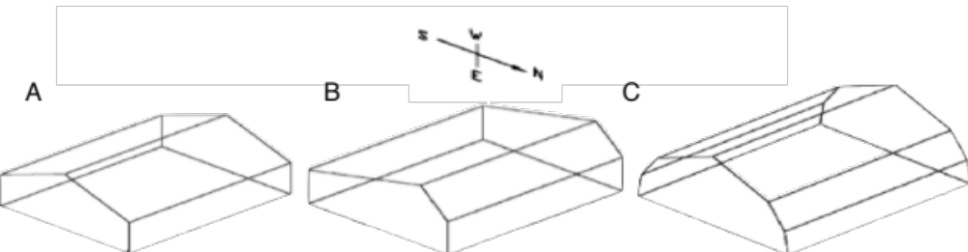

Solar Orientation
Freestanding greenhouses should be oriented east-west in this latitude. Multi-bay, gutter connected or ridge and furrow greenhouses should be oriented north-south. (Roberts et al., 1998) For most efficient solar collection, orientation is always in the east–west direction. (Kumari et al., 2007)
Since the sun's energy is strongest on the southern side of a building, glazing for solar greenhouses should ideally face true south. However, if trees, mountains, or other buildings block the path of the sun when the greenhouse is in a true south orientation, an orientation within 15° to 20° of true south will provide about 90% of the solar capture of a true south orientation. (Bellows, 2003)
Some growers recommend orienting the greenhouse somewhat to the southeast to get the best solar gain in the spring, especially if the greenhouse is used primarily to grow transplants. (White, 1991)
The proper solar orientation for any given location should be calculated before placement of a passive solar greenhouse is finalized. A program from the University of Oregon Solar Radiation Monitoring Laboratory allows the user to find the proper solar orientation. Using a latitude of 43°, the peak solar elevation is ~24° and ~72° during the winter and summer solstice, respectively, at approximately 1230h as seen in Fig. 7. Fig. 8 depicts at where the sun would be in respect to the greenhouse using data from the Fig. 7 graph.

Figure 7: Sun Chart for 43° Latitude in Standard Time Zone (University of Oregon, 2007) 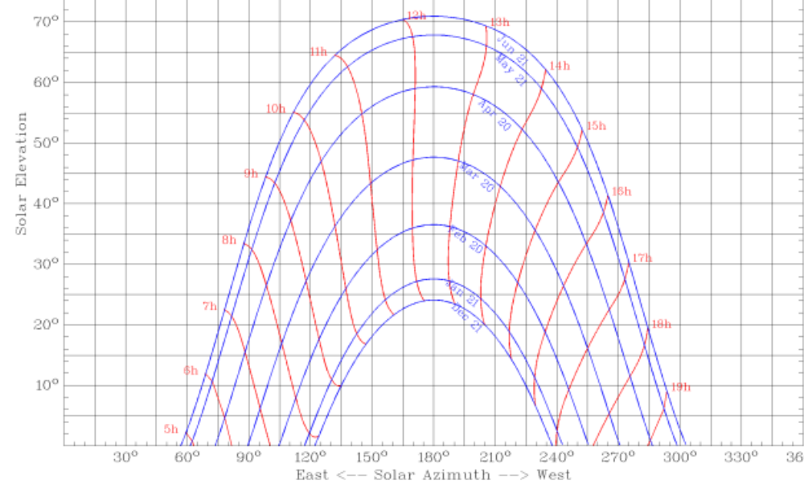 Figure 8: Solar Orientation for True South of a Greenhouse at 43° Latitude in the Standard Time Zone (Bellows, 2003) 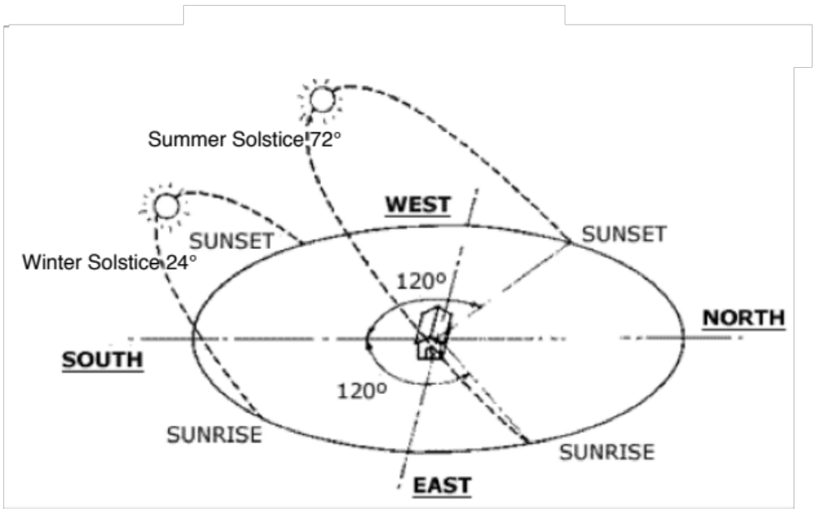

Angle of South Facing Wall
On June 21 the radiation is 3 times that available on December 22nd. (Roberts et al., 1998) Therefore, it is easier to capture the needed solar radiation towards the summer solstice compared with the winter solstice. The greenhouse south facing wall, (also known as glazing) should be properly sloped to absorb the greatest amount of the sun's heat.
Bellows, (2003) summarized their findings to conclude an addition of 10° or 15° to the site latitude will help you achieve the proper angle as a good rule of thumb.
More accurately, the angle of glazing as it is presented to the sun determines the amount of energy which is reflected and the amount which is transmitted is determined by the actual light transmission characteristics of the glazing. The maximum amount of light energy entering the greenhouse occurs when the glazing surface is perpendicular to the sun. (Roberts, 1998)
As seen in the previous section ‘Solar Orientation’, the angle of the sun at 43° latitude during the winter solstice is 24°. If an angle perpendicular to the sun is taken, a roof angle of 66° (90° - 24°= 66°) must be used in order to get maximum absorption on this day. This means that at 12 noon on December 22nd the sun angle would be perpendicular to the roof of the greenhouse if it were at the 66° angle. On the other end of the spectrum, during the summer solstice the perpendicular angle would be 18°. (90° - 72°= 18°)
The design objective is to maximize the light energy entering through the roof of a greenhouse during the time of year when light is at a premium for the grower. (Roberts et al., 1998) If all season growing is the objective of the grower, October to March is when light energy transmission should be maximized. However, if the house is just for starting seedlings, the angle should be optimal for early February.
Not only does a steeper angle allow for a larger live load of wind and snow, but it also prevents snow from accumulating on the roof. A vertical knee-wall should be high enough to accommodate plant beds inside and prevent snow from piling up in front of the house and blocking solar radiation in the winter. (Bellows, 2003)

South Facing Glazing Material
Glazing materials used in solar greenhouses should allow the greatest amount of solar energy to enter into the greenhouse while minimizing energy loss. (Bellows, 2003) Therefore, it is important to choose a material that is available, cost effective and efficient at allowing light transmission and having a high R-value (insulating value). The table below (Fig. 9) was compiled from Bellows, (2003) and Beshada et al., (2006).

Figure 9: Materials and their Transmittance and Insulating Values
Material | Light Transmission | R-Value | Advantages | Disadvantages
Glass - 1 layer | 85-90% | 0.9 | Lifespan indefinite | Easily broken May not hold snow  No light diffusion
Glass - 2 layer | 70-75% | 1.5-2 | Lifespan indefinite | Easily broken Heavy  No light diffusion
Polyethylene - 1 layer | 80-90% | 0.87 | Can resist condensation  Easy Installation  Low Cost | Easily torn  Lasts 2 years  Cannot see through
Polyethylene - 2 layer | 60-80% | 1.5-1.7 | Can resist condensation  Easy Installation  Low Cost | Easily torn  Lasts 2 years  Cannot see through
Polyethylene - Corrugated, high density | 70-75% | 2.0-3.0 | Mildew and water resistant  Does not yellow | Expensive
Polypropylene 8mm | 87% | 1.67 | Resistant to low temp & UV | Lasts 10 years Will turn yellow
Impact modified acrylic - 2 layer | 85% | NA | Not degrated  Resists hail | Glazing expand and contract  Not fire resistant
Fibre Reinforced Plastic | 85-90% | 0.82 | Diffuses light evenly  Lasts 5-20 years | Degrades  Poor weather resistance  Insulation ability does not cause snow to melt
Polycarbonate - Double wall rigid plastic | 83% | 1.6-1.7 | UV, fire resistance  7-10 years | Expensive  Translucent
Polycarbonate Film - quad wall rigid plastic | 75% | 2.0-2.1 | UV, fire resistance  7-10 years | Expensive  Translucent

(Bellows, 2003 & Beshada et al., 2006)

Good plant growth requires that glazing materials allow a natural spectrum of photosynthetically active radiation to enter. Rough-surface glass, double-layer rigid plastic, polycarbonate, polyethylene, and fiberglass diffuse light, while clear glass transmits direct light. Diffuse light passing through glazing evens out the shadows caused by structural supports, (if any are present) resulting in more even plant growth. (Bellows, 2003) However, if structural supports aren’t an issue, the difference between diffuse and direct light is not as much of an issue.
It is also important to note that the method used for mounting the glazing material affects the amount of heat loss. For example, if cracks or holes are caused by the mounting, heat will escape, while differences in the width of the air space between the two glazes will affect heat retention and ultimately the R-value of the wall. (Bellows, 2003)
According to Debevec & MacLean, (1993) plastic had the greatest light transmittance and caused the least depression of photosynthesis of just - 5%. Greenhouses covered with plastic elevated daily maximum and daily mean air temperatures by an average of 7.8°C and 2.0°C. Not only does plastic have a low R-value, but it is also impervious to gases and may negatively alter CO₂ concentrations and humidity within greenhouses.

Thermal Curtains
“A night curtain placed between the crop and the structural cover of greenhouse is called an internal thermal curtain whereas an external curtain is placed between the greenhouse cover and the surrounding atmosphere.” (Ghosel & Tiwari, 2004)
These thermal curtains limit the amount of heat lost through greenhouse glazing during the night and on cloudy days. For small greenhouses, you can manually install the polystyrene sheets at night and remove them in the morning. Thermal blankets made of polyethylene film, foam-back fiberglass can be supported on wire tracks and raised and lowered through automated pulleys. Motorized roll-up systems can store the blankets near the greenhouse peak, (Bellows, 2003) allowing for full transmittance of the incoming solar energy.
The greenhouse built in Elie, Manitoba discussed earlier has an external thermal curtain which is key to the success of that greenhouses heat capacity, as there is just a thin single-layer of plastic used as the glazing material. If a thermal blanket were to be used, it is important to control exactly when thermal transmittance is high enough to be able to remove. Beshada et al., (2006) found the indoor temperature started to rise as soon as the thermal blanket was rolled up at 9:00h and started to decrease after 16:00h. The highest temperature inside the greenhouse was recorded in the afternoon between 13:00h and 16:00h. (Beshada et al., 2006)

Excess Heat / Ventilation
While passive solar heating for greenhouses requires many of the same principles for heating buildings, not all apply for passive solar cooling. It is recommended that mature, well-formed deciduous trees are not used for shade during the summer outside the greenhouse, as they will screen more than 40% of the winter sunlight passing through it’s branches, even when it has no leaves. (Bellows, 2003)
If a greenhouse is under a deciduous tree in the summer it might pose problems for growing plants, as the passing solar wavelengths will be altered towards more far-red light which can be unfavourable to many plants.
Shading with man-made materials is a cheap, easy and effective method of controlling excessive solar radiation in the summer. Sethi & Sharma, (2007) found the use of aluminized reflector sheets could lower the greenhouse temperature by 3–6°C in mild summer conditions as compared to the control greenhouse when temperatures reached 30-40°C.
Air flow is also required to provide adequate levels of carbon dioxide and for controlling humidity, (Bellows, 2003) during the summer months if the greenhouse is still in use.

Previous Design
A passive solar greenhouse was built by Bert Cranmer in 1982 that models many of the concepts already explained in this paper. The cross-section of the greenhouse is approximately 2.41m high and 2.37m wide as seen in Fig. 10.

Figure 10: Previous Passive Solar Greenhouse Cross Section Measurements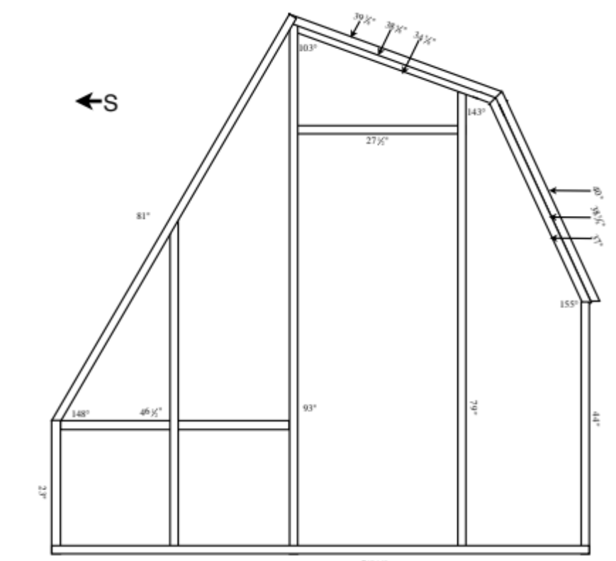

The greenhouse was built mainly to propagate seedlings in the spring, so an angle of 58° was used to take advantage of the solar angle when seeds needed to be started around February 1st. The main heat and light requirements for this greenhouse were from February to April. The excelite glazing material that was used had poor light transmission qualities which wasn’t factored in when materials where chosen.
Fig. 11 Depicts the greenhouse as seen as of July, 2010. It had been over 15 years since it has been used and therefore the plants surrounding it have not been trimmed back to allow optimum solar transmittance to occur.

Figure 11: Passive Solar Greenhouse built for Early Season Propagation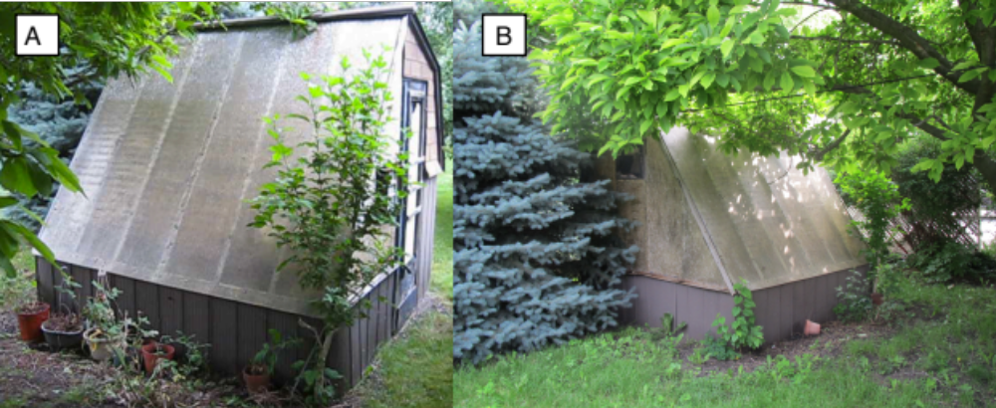
The foundation/floor consists of approximately 20cm gravel which was separated from the ‘B’ soil horizon by styrofoam (Dow SM extruded polystyrene insulation, R=10) The north wall contains 2x4’s with 10 inches between frames filled with fiberglass pink insulation. Corrugated galvanized sheet steel (2mm) was used for around the lower portions of the greenhouse and asphalt shingles were used on the north roof.

Proposed Design
Using the literature review in the previous section as a guide of what methods are efficient and effective, a design will be proposed for a <100 square foot greenhouse that maintains an internal temperature of 10°C without a back-up heat source. The following sections in ‘Proposed Design’ will summarize the topics introduced earlier and how this design will implement them.
Passive Solar Greenhouse Type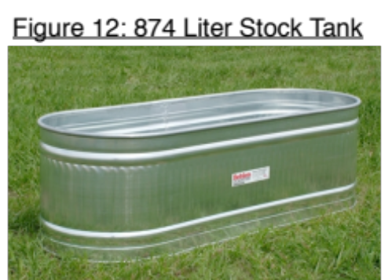
Water Heat Storage
The proposed greenhouse will use mainly water storage as it’s passive solar heat source. The use of a 84 lb. stock tank with a capacity of 874 liters (231 US Gal.) This tank has a heavy zinc coating that protects it against extreme weather conditions that may cause corrosion. The tank is approximately 2‘x3’6‘ in height, width and length. (Fig. 12) (TSC stores, 2011)
The stock tank will be placed under the plant bench on the south side of the greenhouse and will be insulated from the interior walls to ensure no collected heat is lost. The top will be covered with a corrugated white plastic cover with some external support fastened by leg bolts.
Sealed smaller-sized glass bottles with a high surface area to volume ratio will be placed on shelves on the north wall to further increase the heat capacity of the greenhouse.

Rock Bed Storage
Additional heat storage will be added in the form of gravel inside the greenhouse. As found in the previous design, the gravel will be separated from the ‘B’ soil horizon by styrofoam (Dow SM extruded polystyrene insulation, R=10) and the ‘A’ soil horizon and organic matter will be removed from the future greenhouse location.

North Wall
The north wall is being designed purely for insulation purposes as it will have a low heat capacity as seen in Fig. 13. Corrugated galvanized sheet steel (2mm) will be used on the exterior surface with Tyvek paper directly underneath to allow the steel to breath. 102mm of fiberglass will be filled as the next layer. Half-inch exterior-grade plywood will be fastened to spruce 2x4 studs found in the same section as the fiberglass. Vapour barrier will be put between the plywood and extruded polystyrene insulation (25mm). The interior surface will be corrugated galvanized sheet steel painted with a white reflective coating capable of reflecting ~90% of incident solar radiation as found by Harz et al., (1981) allowing incoming heat to be stored elsewhere in the greenhouse. The interior steel will be fastened to the plywood using 2” screws.
Figure 13: Materials found in the North Wall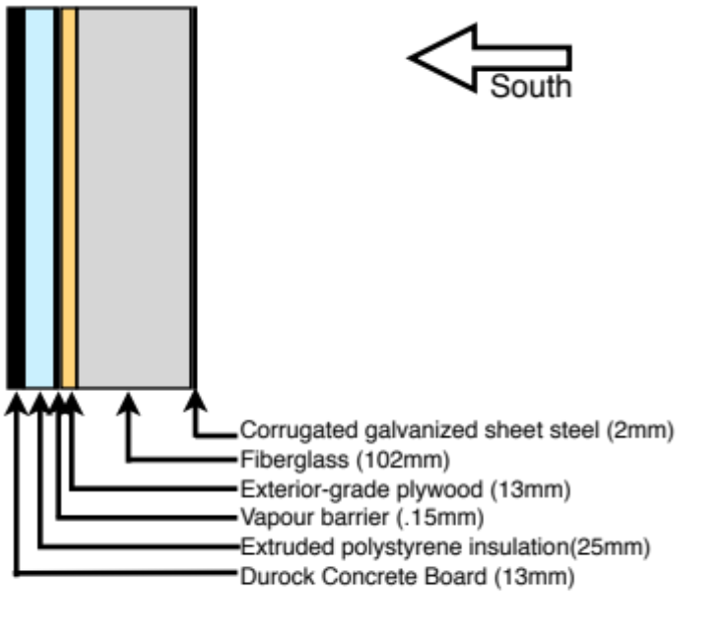
Structure & Shape
This design is using an uneven span as referred to by Kumari et al., (2007) and seen in Fig. 6(B) and Fig 18.

Angles Involved
Using Bellows, (2003) summarized method, the glazing should be sloped at an angle of 58°. (43° + 15°= 58°) However, if the sun chart for 43° latitude from the University of Oregon program is used to find the winter solstice sun angle, the angle perpendicular to the sun is 66° from the horizon. (90° - 24°= 66°) To maximize energy intake during the winter, the 66° angle will be used so that the best solar efficiency will occur on the day that theoretically should have the least amount of light.
A knee-wall of 24” will be used to ensure heavy winter snowfalls will not shade the interior of the greenhouse. Since the south side of the greenhouse is sloped to such a steep angle, it is unlikely that snow will not slide down to the knee-wall.

Solar Orientation
For most efficient solar collection, the orientation of this greenhouse will be facing directly true south.

South Facing Material/ Glazing
Double pane glass provides a R-value of 2 while high density corrugated polyethylene has a R-value up to 3. Both have a light transmission of 70-75%, but not only is polyethylene expensive, but it is only guaranteed for 10 years before it may start to degrade. Double pane glass will last indefinitely as long as it doesn’t break.

Thermal Curtains
To increase the R-value on the south facing glazing during the night, a thermal blanket on a spindle is proposed. Although it would require 2 minutes every morning and night to cover and uncover the greenhouse, the thermal gains would be rewarding.

Having automated curtains would be an asset to keep the heat in during the cold winter nights. However, such a system would require a timer, motor, automatic shut-off switch and a track with a roll-up thermal curtain material. While this is possible, it would be beneficial to test the greenhouse out for a year first to see if they are warranted. Depending on what materials are available, an automated system could be interior or exterior.
Another option is framing polystyrene and placing the frames on the interior of the greenhouse. These frames would have to be removed every morning and placed every evening, but they would provide a higher R-value causing less heat to escape. If a week of cloudy weather occurred it might be beneficial to create such frames.

Excess Heat / Ventilation
On days where the water can no longer buffer the temperature a heat activated window opener will be used to open a panel on the upper west side of the greenhouse. The window opener works by using a gas-charged cylinder to expand as temperature rises. A simple adjustment lets you control the operating range depending on the crop and the time of year. It will lift up to 15 lb.

Figure 14: Heat Activated Window Opener (Lee Valley, 2011)
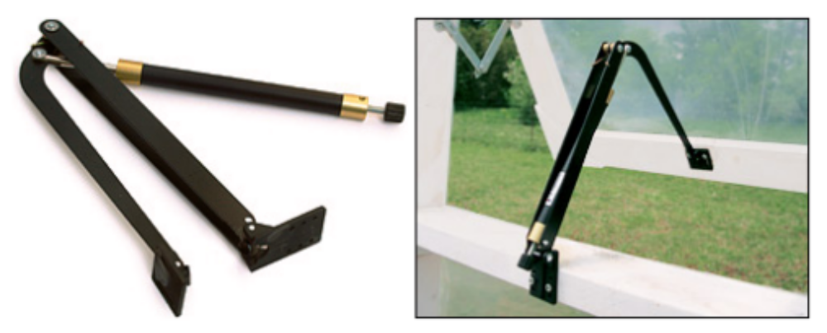 Additionally, a lattice constructed of 1x1.5” spruce painted black will block half the sunlight through the summer months and provide even shading on the exterior of the glazing. It will be used from July-August.

Additional Features
This section includes ideas not necessarily found in the literature but will be included in this passive solar greenhouse design.

Double Entry Door/Potting Room
Most greenhouses have a single entry door which when opened, allows for large quantities of heat to escape from the interior. A double entry door would allow for only the air inside this entrance to escape, as long as only one door was open at a time. It is suggested that the greenhouse shape be continued on an additional 4’ to allow for a potting room and additional door on the east side. Fig. 15 gives approximate measurements for the potting room from a aerial point of view. (Cranmer, 2011)

Figure 15: Aerial View of Greenhouse with Potting Room Addition

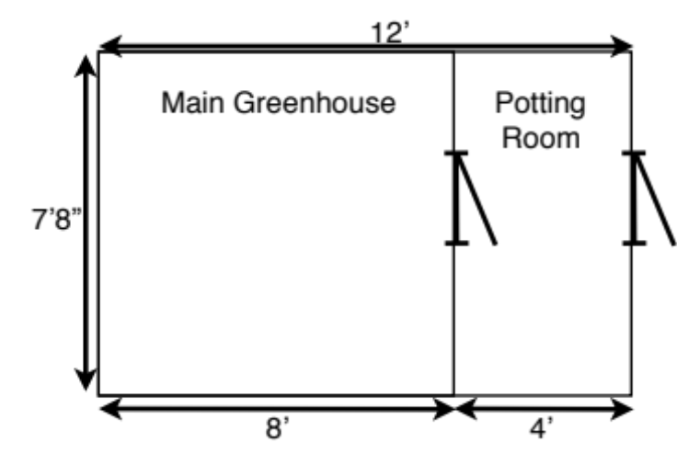
Active Water Heat Storage
As mentioned earlier, the stock tank will be placed under the south bench and will not be in any direct sunlight. The objective is to get the water in the stock tank as warm as possible throughout the day. Water pumping through a loop system to pipes located on the ceiling of the greenhouse would take heat as it rises and redistribute it to the stock tank for use later. The bilge pump will be connected to a solar panel placed on the south side of the potting room. The solar panel will only create electricity powering the pump only when there is enough solar energy. This will speed up the heat absorption of the stock tank throughout the day only when the sun is available. At night heat will rise directly below the plants from the stock tank as the external temperature decreases.
The pump used to move the water will be a 12V bilge pump available at Princess Auto, (2011) as seen in Fig. 16A. It has a 643LPH (170GPH) capacity and will pump to a head height of 8’. Running at peak output, it will move all the water from the stock tank throughout the greenhouse loop system every hour and twenty minutes.
The closed loop system will consist of a black tube the same diameter as the output on the bilge pump going from the bilge pump located in the stock tank to the top of the greenhouse. The black tube will feed into copper pipes coiled/placed along the roof of the greenhouse to absorb incoming heat. A black tube of equal diameter to the input to the copper pipes will lead the water back down to the stock tank to close the circuit.
To power the bilge pump a 15W amorphous solar panel with 7A charge controller
from Princess Auto, (2011) will be used. This panel (as seen in Fig. 16B) will be mounted on the potting shed south-facing roof with the ability to change the tilt. Gunerhan & Hapbasi, (2007) recommend the solar collector should be mounted at the monthly average tilt angle with the slope being adjusted once a month.

Figure 16: 20.4W Bilge Pump (A) and 15W Solar Panel (B) (not to scale)
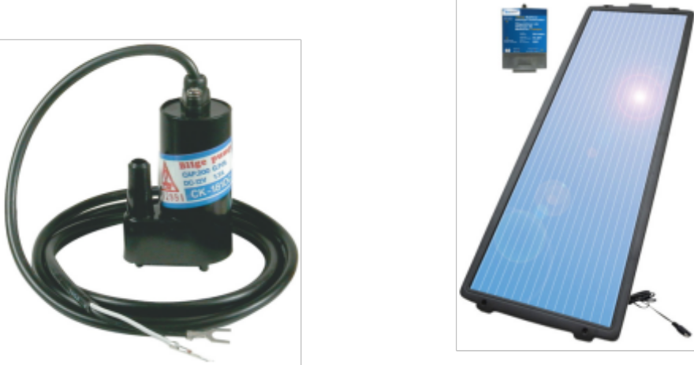
Min/Max Thermometer
It is important to know the range of temperatures encountered inside the greenhouse, especially for tender crops. Therefore, a min-max thermometer will be used as a way to keep track of the highs and lows. While it doesn’t need a CPU or electrical source, in order to keep track of the temperatures on a daily basis it must be reset by hand. The 5” thermometer (as seen in Fig. 17) will be mounted at plant height inside the greenhouse.

Figure 17: Min-Max Thermometer (Lee Valley, 2011)
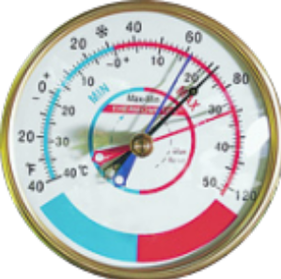

Blueprints
Figure 18: View from the East looking West-External Wall 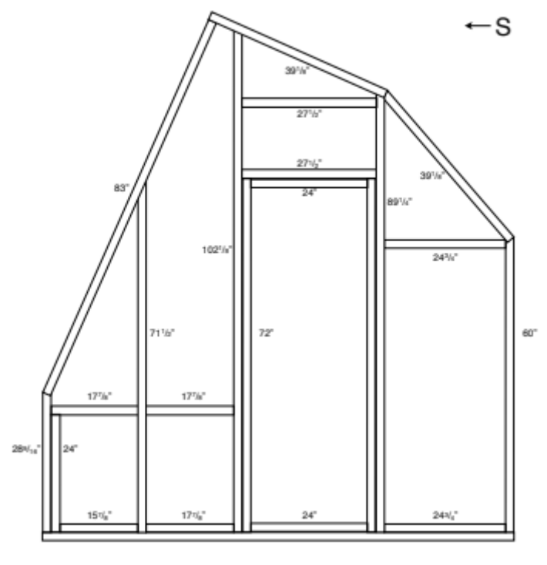

Figure 19: View from the East looking West-Inner Wall between Potting Room & Greenhouse
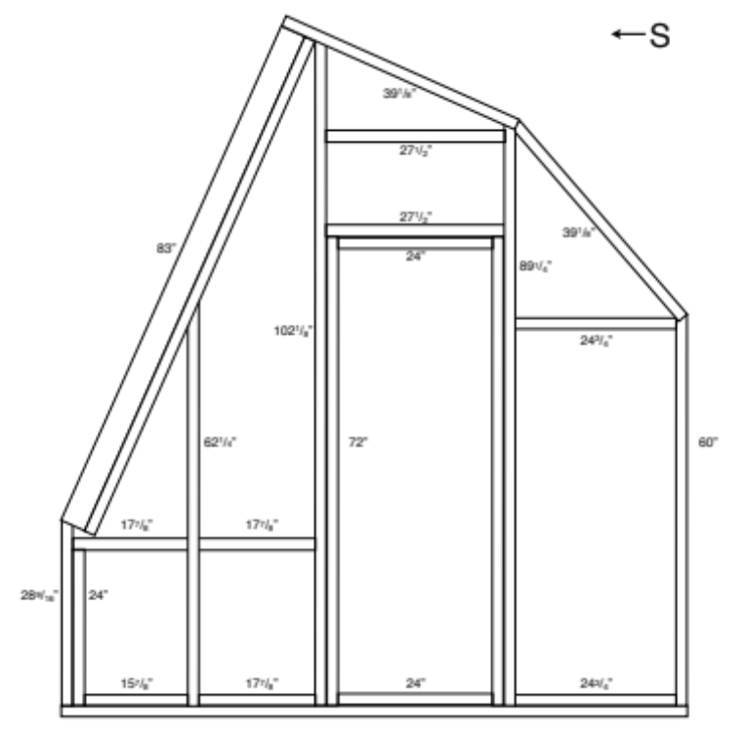

Figure 20: View from the East looking West-Support Wall
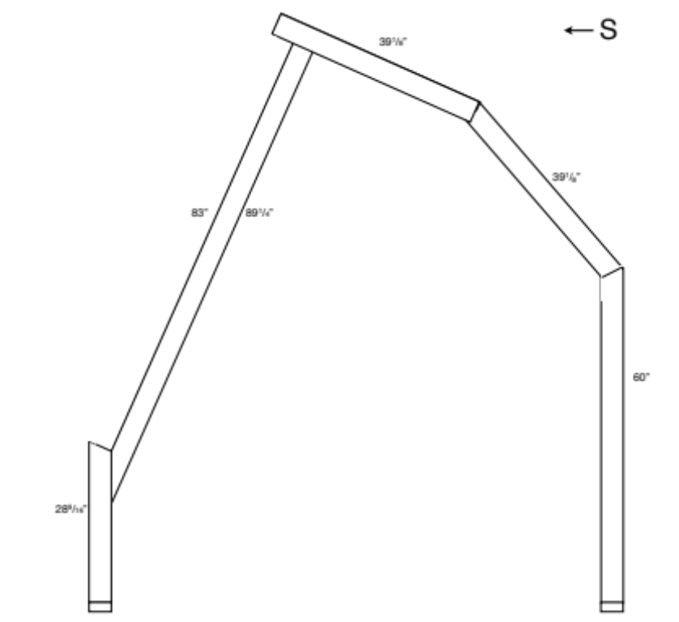

Figure 21: View of West External Wall facing West
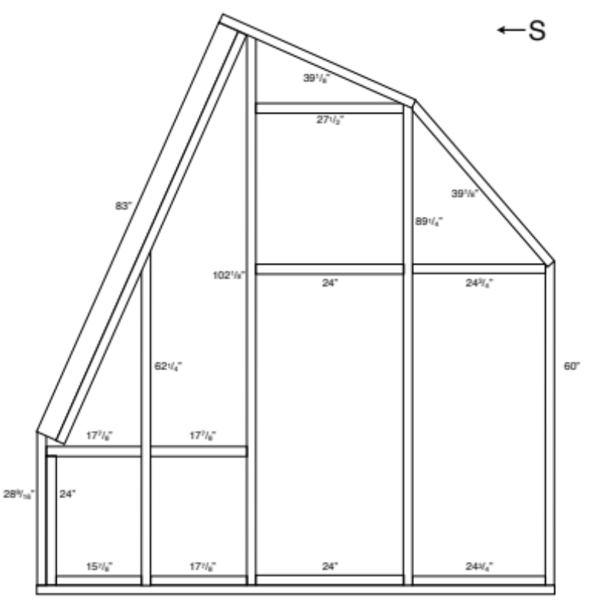

Figure 22: View from the South facing North
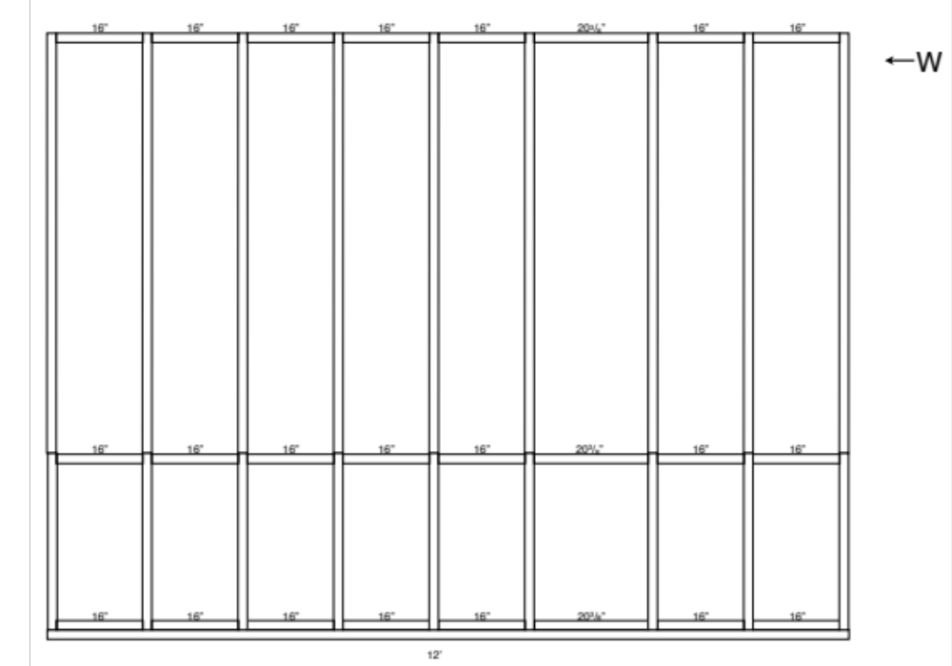

Figure 23: View from the North facing South
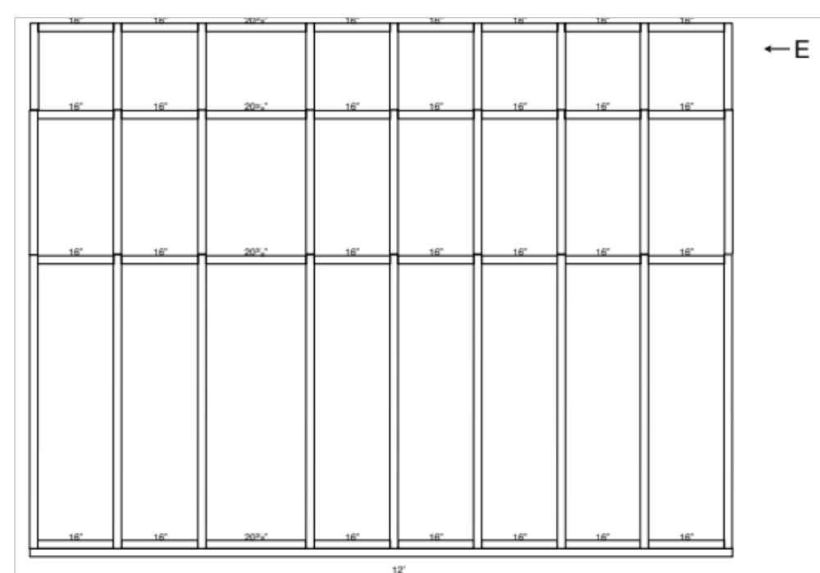
Construction

Materials Chosen
Materials chosen will be purchased from local Canadian suppliers to limit the carbon footprint of the greenhouse and to support the local economy. Privately owned businesses will come before a big box store whenever possible. Glass used for the glazing will be recycled from patio doors as it generally is already 80” long. Two panels is all that will be needed to cover the width of the greenhouse. Glass is advantageous because it has an indefinite lifetime. Therefore, little upkeep will be required to keep this greenhouse in working order.

Tools Required
The following list describes materials that will not be used in the process of manufacturing a greenhouse, but is not used up in the process:
Mitre saw
Band saw
Power drill
Drill press
Drill bits
Chaulking gun
Glass cutter
Table sander
Sand paper
Steel wool
Paint brushes
Hammer
Screwdrivers
Socket set
Extension cord
Metal cutter
Square
Writing materials

References
Anderson, B., & Michal, C. (1978). Passive Solar Design. Ann. Rev. Energy, 3, 57-100.
Bavel, V., Damagnez, J., & Sadler, E. (1981). The Fluid-Roof Solar Greenhouse: Energy Budget Anaylsis by Simulation. Agricultural Meteorology, 23, 61-76.
Bellows, B. (2003). Solar Greenhouses. ATTRA - National Sustainable Agriculture Information Service, 1-33.
Beshada, E., & Zhang, Q. B. (2006). Winter performance of a solar energy greenhouse in southern Manitoba. Canadian Biosystems Engineering, 48, 5.1-5.8.
Debevec, E., & MacLean, S. (1993). of Greenhouse for use in the Tundra. Plant Design Manipulation Temperature Communities. Arctic and Alpine Research, 25 (1), 56-62.
Ecolad Corp. (2011). Robson Greenhouse Kits - Five Wall Polycarbonate - 8' x 12'. Retrieved 10 30, 2011, from Backyard Greenhouses: http://backyardgreenhouses.ca/ecom.asp?pg=products&specific=jphmdmg4&gotogrp=457&gotopgnum=1
Gauthier, C., Lacroix, M., & Bernier, H. (1997). Numerical Simulation of Soil Heat Exchanger-Storage Systems for Greenhouses. Solar Energy, 60 (6), 333-346.
Ghosal, M., & Tiwari, G. (2004). Mathematical modeling for greenhouse heating by using thermal curtain and geothermal energy. Solar Energy, 76, 603-613.
Givoni, B. (1991). Characteristics, Design Implications and Applicability of Passive Solar Heating Systems for Buildings. Solar Energy, 47 (6), 425-435.
Gunerhan, H., & Hepbasli, A. (2007). Determination of the optimum tilt angle of solar collectors for building applications. Building and Environment, 42, 779-783.
Hartz, T., Lewis, A., & Hughes, H. (1981). Performance of a modified Brace Institute Greenhouse in Virginia. HortScience, 16 (74), 748-752.
Hastings, R. (1995). Myths in Passive Solar Design. Solar Energy, 55 (6), 445-451.
Jain, D., & Tiwari, G. (2003). Modeling and optimal design of ground air collector for heating in controlled environment greenhouse. Energy Conversion and Management, 33, 1357-1372.
Jordan, R. (1981). Patent No. 84448. Calif.
Kumari, N., Tiwari, G., & Sodha, M. (2007). Performance Evaluation of Greenhouse having Passive or Active Heating in Different Climatic Zones of India. Agricultural Engineering International, 9, 1-19.
Kurklu, A., Bilgin, S., & Ozkan, B. (2003). A study on the solar energy storing rock-bed to heat a polyethylene tunnel type greenhouse. Renewable Energy, 28, 683-697.
Lee Valley & Veritas. (2011). Heat-Activated Window Opener. Retrieved 10 30, 2011, from Lee Valley and Veritas: http://www.leevalley.com/en/garden/page.aspx?cat=2,43224&p=10543
Lee Valley Tools. (2011). Min-Max Thermometer. Retrieved 10 20, 2011, from Lee Valley & Veritas: http://www.leevalley.com/en/garden/page.aspx?cat=2,43224&p=60068
Morrison, G. (1980). Passive Energy Storage in Greenhouses. Solar Energy, 25, 365-372.
Pavlou, G. (1990). Evaluation of Thermal Performance of Water-Filled Polyethylene Tubes Used For Passive Solar Greenhouse Heating. Acta Horticulturae, 287, 89-97.
Princess Auto. (2011). 15W Amorphous Solar Panel with 7A Charge Controller. Retrieved 11 19, 2011, from The Unique World of Princess Auto: http://www.princessauto.com/all-seasons/outdoor/green-products/renewable-energy/8125155-15w-amorphous-solar-panel-with-7a-charge-controller
Princess Auto. (2011). Bilge Pump. Retrieved 11 19, 2011, from The Unique World of Princess Auto: http://www.princessauto.com/all-seasons/seasonal/pumps/electric/4270013-bilge-pump
Roberts, W. (1998). Glazing Materials, Structural Design, and Other Factors Affecting Light Transmission in Greenhouses. Greenhouse Glazing & Solar Radiation Transmission Workshop, 1-8.
Santamouris, M., & Lefas, C. (1986). Thermal Analysis and Computer Control of Hybrid Greenhouses with subsurface Heat Storage. Energy in Agriculture, 5, 161-173.
Santamouris, M., Argiriou, A., & Vallindras, M. (1994a). Design and Opperation of a Low Energy Consumption Passive Solar Agricultural Greenhouse. Solar Energy, 52 (5), 371-378.
Santamouris, M., Balaras, C., Dascalaki, E., & Vallindras, M. (1994b). Pasive Solar Agricultural Greenhouses: A Worldwide Classification and Evaluation of Technologies and Systems Used for Heating Purposes. Solar Energy, 53 (5), 411-426.
Sethi, V., & Sharma, S. (2007). Survey of cooling technologies for worldwide agricultural greenhouse applications. Solar Energy, 81, 1447-1459.
Singh, R., & Tiwari, G. (2000). Thermal heating of controlled environment greenhouse: a transient analysis. Energy Conversion and Management, 41, 505-522.
Sturdi-built Greenhouse Manufacturing Co. (2011). Greenhouse kits - Solite. Retrieved 10 30, 2011, from Sturdi-built Greenhouses: http://www.sturdi-built.com/greenhouse-styles-sizes/greenhouse-kits---solite.php
The Home Depot. (n.d.). Palram Deluxe Nature Series Greenhouse, Green - 6 Feet x 8 Feet. Retrieved 10 30, 2011, from Home Depot Canada Products: http://www.homedepot.ca/product/deluxe-nature-series-greenhouse-green-6-feet-x-8-feet/924873
TSC Stores. (2011). Behlen Country Stock Tank 3'x2'x6' 231 US Gal. Retrieved 10 15, 2011, from TSC Stores: http://www.tscstores.com/Tank-Stock-3x2x6-231-US-Gal-P3654.aspx
University of Oregon. (2007, 03 05). Sun path Chart Program. Retrieved 11 21, 2011, from University of Oregon Solar Radiation Monitoring Laboratory: http://solardat.uoregon.edu/SunChartProgram.html
White, J. (1991). Growing it in a Sunpit. The Natural Farmer (Winter), 14.
Zweig, R. (1986). An Integrated Fish Culture Hydroponic Vegetable Production System. Aquaculture Magazine, May/June, 34-40.

